Project Design Phase-II Technology Stack (Architecture & Stack)

|  |  |
| --- | --- |
| Date | 25 October 2022 |
| Team ID | PNT2022TMID24349 |
| Project Name | A Novel Method for Handwritten Digit Recognition System |
| Maximum Marks | 4 Marks |

Technical Architecture for Handwritten Digit Recognition System:

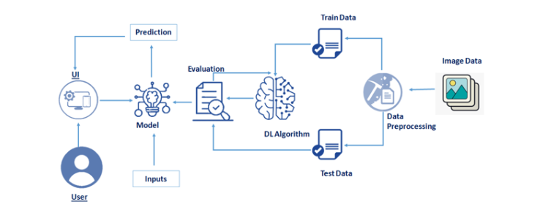

Table-1: Components & Technologies:

|  |  |  |  |
| --- | --- | --- | --- |
| **S.No** | **Component** | **Description** | **Technology** |
| 1. | User Interface | User interacts with the application using a web app | HTML, CSS, JavaScript / Angular Js / React Js etc. |
| 2. | Application Logic | Login to access the application | Java / Python |
| 5. | Database | Data Type, Configurations etc. | MySQL, NoSQL, etc. |
| 6. | Cloud Database | Database Service on Cloud | IBM DB2, IBM Cloudant etc. |
| 7. | File Storage | Storage of user files of handwritten image | IBM Block Storage or Other Storage Service or Local Filesystem |
| 10. | Machine Learning Model | Machine learning model is used to identify the handwritten image uploaded by users | Object Recognition Model, etc. |
| 11. | Infrastructure (Server / Cloud) | Application Deployment on Local System / AI Local Server Configuration  AI Server Configuration | Local, Cloud Foundry, Kubernetes, etc. |

Table-2: Application Characteristics:

|  |  |  |  |
| --- | --- | --- | --- |
| **S.No** | **Characteristics** | **Description** | **Technology** |
| 1. | Open-Source Frameworks | Machine learning frameworks is used to train a predictive model | PyTorch, Open-cv |
| 2. | Security Implementations | The system should automatically be able to authenticate all users with their unique username and password | Password based login, Authorization |
| 3. | Scalable Architecture | The website traffic limit must be scalable enough to support 2 lakhs users at a time | 3-tier |
| 4. | Availability | The system functionality and services are available for use with all operations. | distributed servers |
| 5. | Performance | The application can give response to requests within 5 sec. It uses fewer features to train the neural network, which results in faster convergence. | number of requests per sec |